REPORT

DEEPFAKE DETECTION

GUIDED BY: PROF. SAGAR APUNE
TY BTECH CSE CSF PANEL-A

TEAM MEMBERS
SR. NO. | ROLL NO. | PRN | NAME
1. | 71 | 1032233557 | SHUBHANGI GUPTA
2. | 55 | 1032232744 | VINEET ANANT MANAGE
3. | 75 | 1032233853 | HIMANSHU RAJ PRAKASH
4. | 68 | 1032233187 | SANYAM SHARMA

Deepfake Detection and Analysis Web Application
ABSTRACT
The Deepfake Detection and Analysis Web Application is a full-stack project that helps identify whether a media file is real or fake.
The system allows users to upload files, checks the authenticity using backend logic, and then stores the results in a database.
The application also includes an analysis dashboard that visually represents the number of real and fake files and their accuracy through charts and graphs.
The project is built using React.js for the frontend, Node.js and Express.js for the backend, and MongoDB for the database.
The goal was to create a complete and functional web system that combines frontend design, backend logic, and database management in one application.
INTRODUCTION
Background
With the rapid growth of artificial intelligence, fake media known as deepfakes are becoming a serious problem. Detecting these fakes manually is difficult, time-consuming, and often inaccurate.
This project was developed to demonstrate how a full-stack web application can help automate this process, store the results, and display them in an easy-to-understand format.
Problem Statement
Identifying whether a video or image is fake is a growing concern in today’s digital world.
This project aims to provide a simple, user-friendly web solution that detects fake media and stores the results for later analysis.
Objectives
- To design a clean and responsive web interface for file uploads.
- To connect frontend and backend using API calls.
- To store each file’s detection result in MongoDB.
- To display visual reports (pie chart and bar chart) showing overall statistics.
Scope
This project focuses mainly on the frontend, backend, and database integration aspects of full stack development.
The deepfake detection result is simulated (using backend logic) rather than generated by an AI model.

System Overview
Frontend
The frontend is designed using React.js with a dark (black and red) aesthetic theme.
It contains three main pages:
- Upload Page: For uploading image or video files. 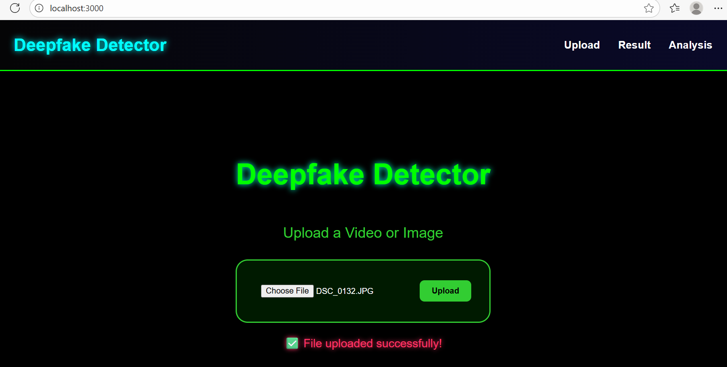
- Result Page: Shows whether the uploaded file is “Real” or “Fake” along with accuracy. 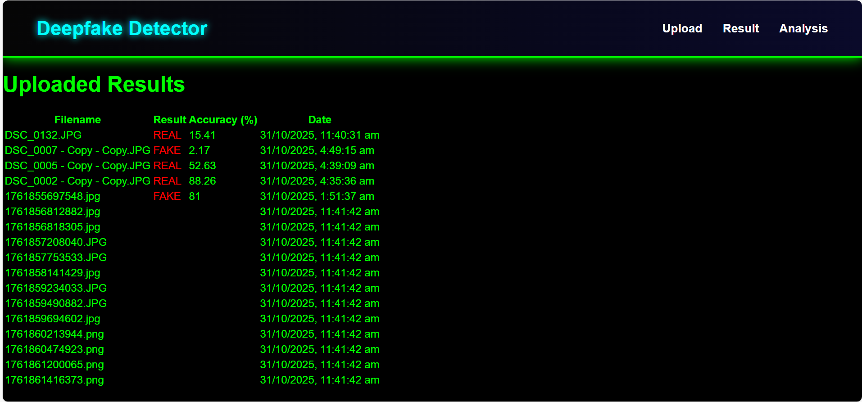
- Analysis Page: Displays graphical summaries using Recharts (pie and bar charts). 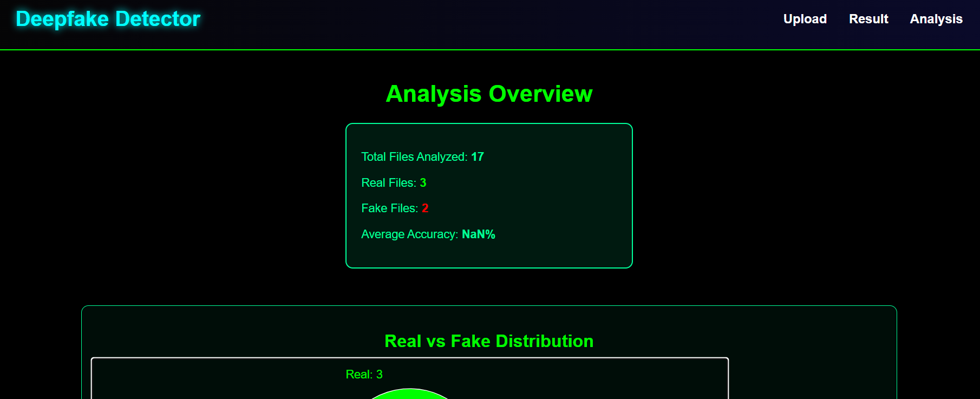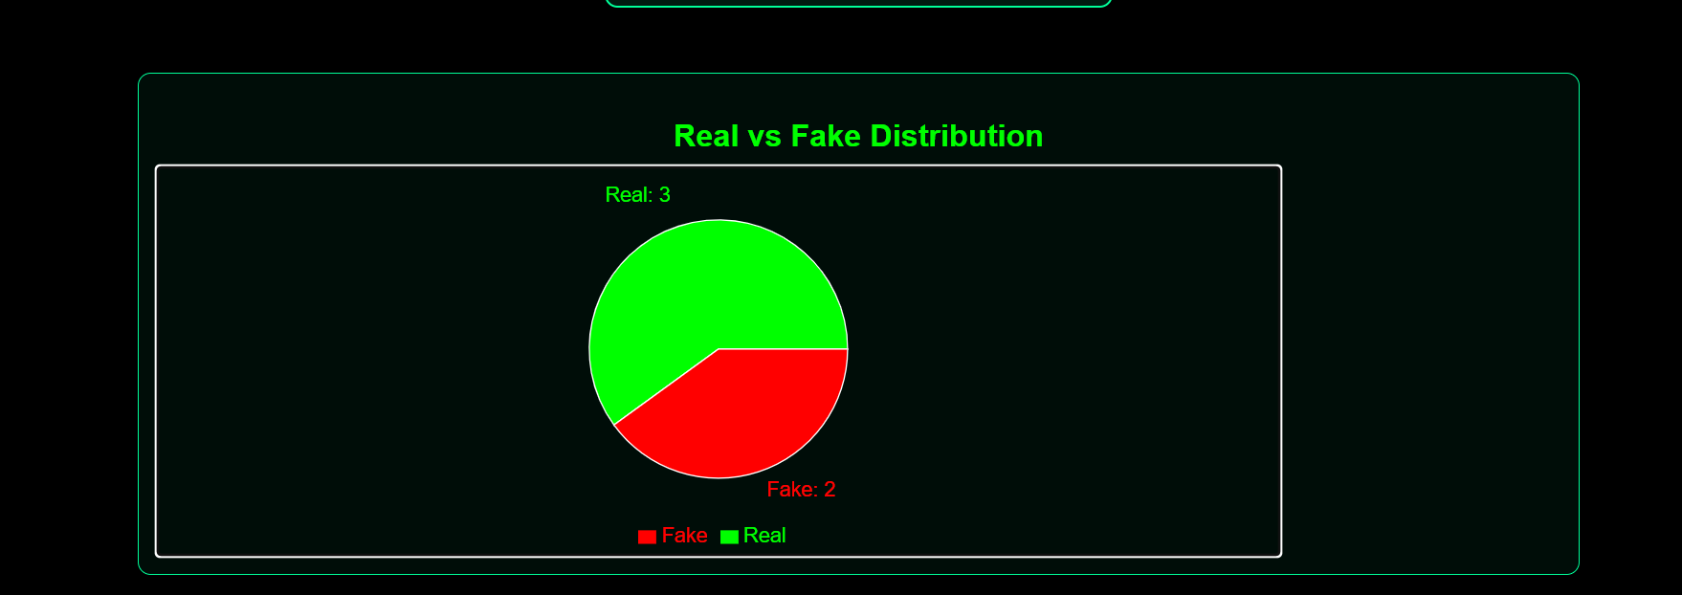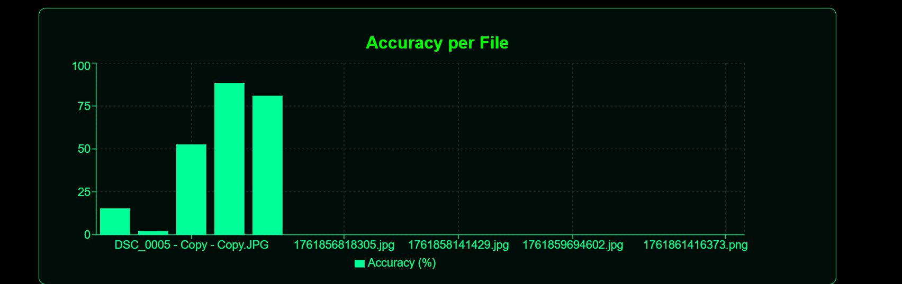
Backend
The backend is created using Node.js and Express.js.
It handles routes for:
- /upload — Receives uploaded files and stores their result.
- /results — Fetches all previous detection results.
- /analysis — Provides summary data for charts.
Database
The MongoDB database stores every upload record with:
- Filename
- Detection result (Real/Fake)
- Accuracy percentage
- Timestamp
This data is then used by the analysis page to create summary statistics and visual reports.

DEVELOPMENT PROCESS
- Setup MongoDB and Backend — Created Express server, set up routes, and connected MongoDB.
- Create Frontend with React — Designed pages and navigation using React Router.
- Connect Frontend to Backend — Used Axios to call backend APIs for upload, result, and analysis.
- Add Chart Visualization — Used Recharts library to show data in pie and bar charts.
- Testing — Uploaded files, verified database entries, and checked graph accuracy.
- Styling and UI Polish — Applied black-red theme and modern fonts for a professional look.

RESULTS
After implementing all modules, the web application successfully allowed users to:
- Upload files for deepfake detection.
- View the classification result (Real/Fake) with accuracy.
- Analyze uploaded data through visual graphs.
Sample Output Table
Filename | Result | Accuracy (%)
face1.jpg | Real | 96.2
fake2.mp4 | Fake | 88.5
clip3.mp4 | Real | 92.4
Analysis Page Visuals
- Pie Chart: Shows proportion of real vs fake files.
- Bar Chart: Displays accuracy percentage for each uploaded file.

CONCLUSION
The Deepfake Detection and Analysis Web App demonstrates how a complete full-stack project can be developed by combining a beautiful frontend, a reliable backend, and a connected database.
It successfully meets the objectives of the mini project by allowing users to upload media, get simulated detection results, and visualize data through charts.
FUTURE ENHANCEMENTS
- Integrating a real deep learning model for actual deepfake detection.
- Adding a user login system for personalized analytics.
- Hosting the app on cloud platforms for live access.

TOOLS AND TECHNOLOGIES USED
Layer | Tools / Technologies
Frontend | React.js, Axios, Recharts, CSS
Backend | Node.js, Express.js
Database | MongoDB
Environment | Visual Studio Code
Styling | Black and Red Theme, Poppins Font

REFERENCES
- React.js Documentation – https://react.dev
- Express.js Official Docs – https://expressjs.com
- MongoDB Documentation – https://www.mongodb.com/docs
- Recharts Library – https://recharts.org

